**St. Francis Institute of Technology**

**Class: SE-ITA/ITB Semester: IV; A.Y. 2023-2024**

**Subject: Microprocessor Lab**

**Experiment – 5:** Count the number of 1’s and 0’s for a 16-bit number

**1. Aim**:

Write an ALP to count the number of 1’s and 0’s for a 16-bit number.

**2. Requirements**

DOSBox (an x86 emulator with DOS), Turbo Assembler, Turbo Debugger

**3. Pre-Experiment Exercise**

**Algorithm:**

a. Initialize the data segment. Load the 16 bit number in the AX register.

b. Initialize BX register as a counter for zeros and DX register as a counter for ones. c. Initialize CX as a counter register.

d. Keep rotating the AX register by 1 till the counter becomes zero.

e. While rotating if carry is set, increment DX register, if carry is clear, increment BX. f. Store the result from DX and BX register in two separate memory locations. g. Stop

**4. Laboratory Exercise:**

**Procedure:**

a. Open DOSbox and go to TASM.

b. Open a new document using the command - edit <filename>.asm

c. Write the Program and save the changes to the same file.

d. Assemble the program using the command - tasm <filename.asm>

e. If any errors are displayed, then change the code in <filename>

f. If no errors are displayed, execute command - tlink <filename>.obj to create the executable file. g. Next execute the command - td <filename>

h. Try to RUN the program step by step and view the changes in the registers, flags, memory, etc.

**5. Post Experiment Exercise:**

**a. Results/Calculations/Observations:**

i. Attach appropriate screenshots of internal registers, flag register and memory location along with the ALP.

ii. Draw the flowchart for the above code.

**b. Questions:**

i. Write an ALP in TASM to find whether the number entered is odd or even. Attach appropriate screenshots.

**c. Conclusion:**

Write the conclusion/comments based on the experiment performed and the output obtained. **d. References:**

Mention two book references and two web references.

**POST_EXPERIMENT**   **RIYA INDAP,44**

**a)Write an ALP to count the number of 1’s and 0’s for a 16-bit number.**

model small

stack 10h

data segment

num dw 0A59Eh

zeros dw 00h

ones dw 00h

data ends

code segment

assume cs: code, ds:data

start:

mov ax,data

mov ds, ax

mov ax,num

mov bx,00h

mov dx,00h

mov cx,0010h

up: rol ax,01h

jc one

inc bx

jmp down

one:inc dx

down:loop up

mov zeros,bx

mov ones,dx

mov ah,4ch

int 21h

code ends

end start

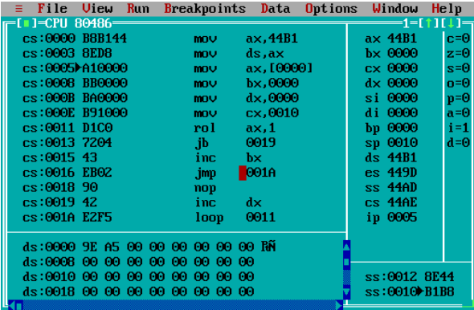

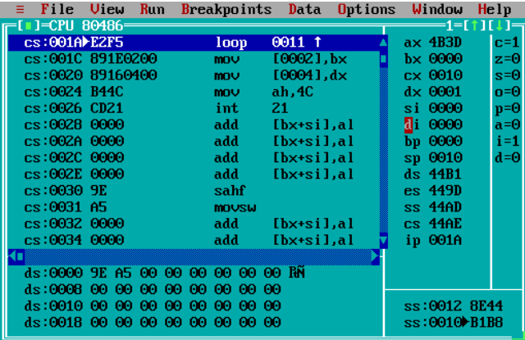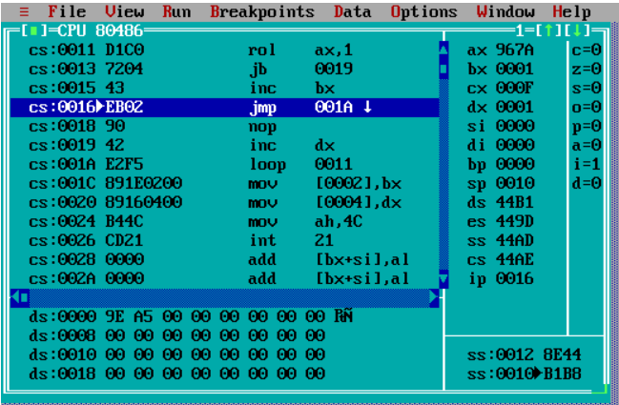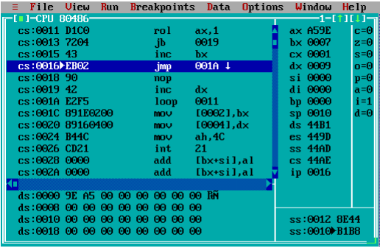

**b)Write an ALP in TASM to find whether the number entered is odd or even.**

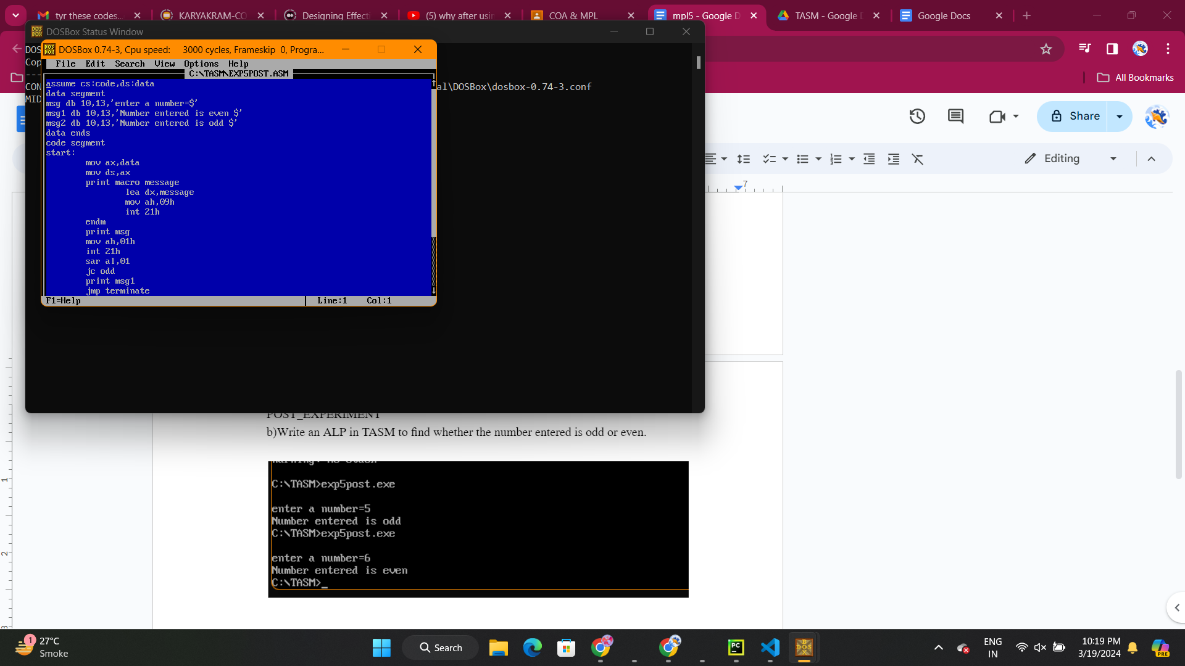

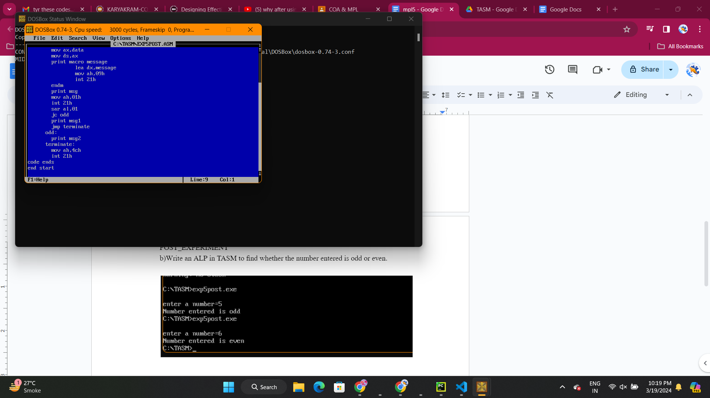

output:

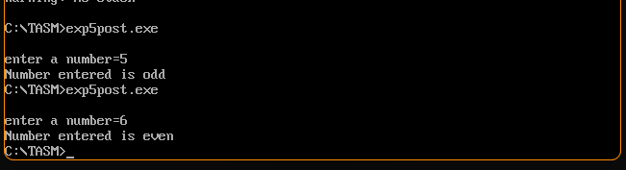

~When odd input is entered.

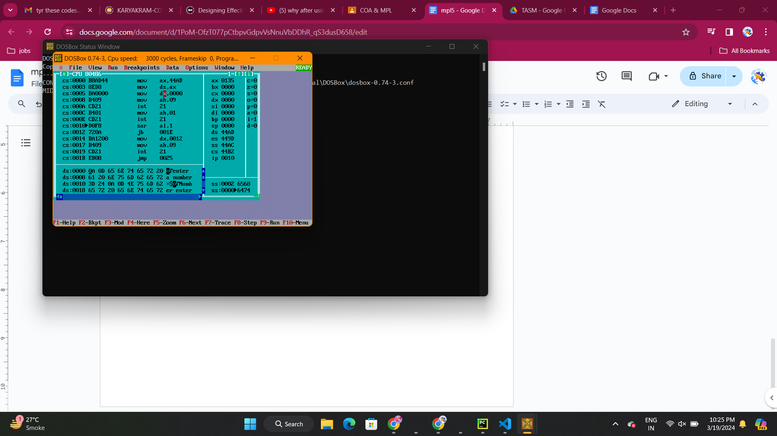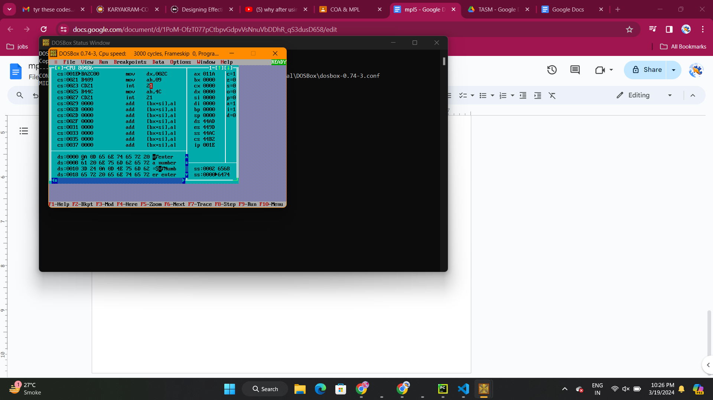

~When even input is entered.

